JAMAL MOHAMED COLLEGE (AUTONOMOUS)
TIRUCHIRAPPALLI – 620 020.
SINCE 1951

GAJA RELIEF ASSISTANCE CAMPAIGN

Jamal Mohamed College wishes to extend helping hands to the victims of Gaja Cyclone.
In this regard, an appeal to our Students / alumni / Donors / Well wishers / General Public
for your generous contribution.

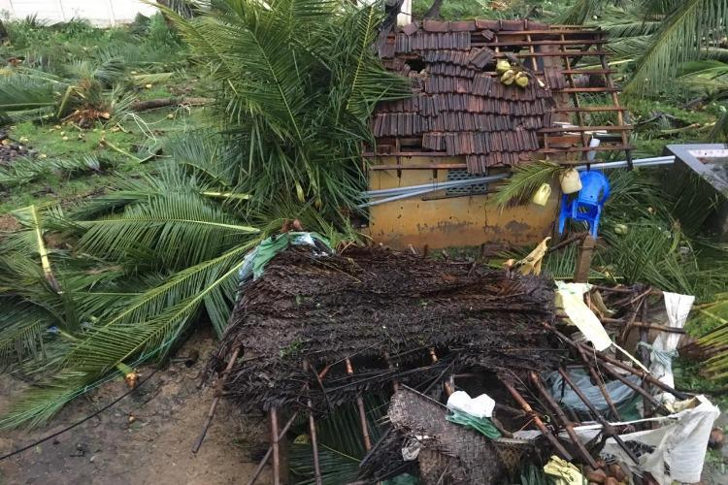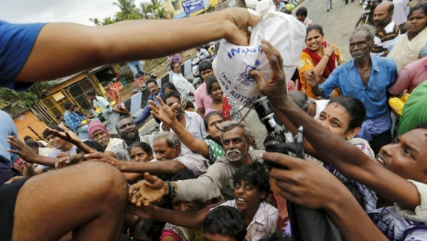

Required materials
- Tea & Coffee Packets  - Biscuits  - Baby Milk Powder  - Sugar  - Mosquito Coils  - Big Candles  - Tarpolins | - Match Boxes  - New Towel & Shawls  - Sanitary Napkins & Diapers  - Toiletries  - New Bed Spreads  - Groceries  - Water

Relief Materials can be handed over at NSS Room, Jamal Mohamed College.
Contribution can be also made in cash or cheque in the name of
The Principal, Jamal Mohamed College
(or) in the form of goods / things / materials

For Money Transfer:
Current Account No : 046702000000009
Account Name : JAMAL MOHAMED COLLEGE
IFSC CODE : IOBA0000467
MICR CODE : 620020010
Branch : IOB JMC BRANCH, TIRUCHIRAPPALLI

Please mention a note as “GAJA CYCLONE RELIEF FUND”
For Further Details contact :
Prof. S. Sheik Ismail – 9443183667 Dr. A. Hidhayathulla – 9443424425
Capt. F.S.Muzammil – 9443672812 Dr. M. Kamaraj – 9942110787
Dr. A. Zahir Hussain – 9865517744 Dr. K. Sheik Fareeth – 9677625779

,iwtd; cq;fs; cUtq;fisNah> nry;tq;fisNah ghh;g;gjpy;iy
khwhf cq;fsJ cs;sq;fisAk;> nray;fisAk; ghh;f;fpd;whd;. – egpnkhop.

