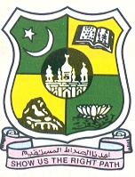
JAMAL MOHAMED COLLEGE (Autonomous)

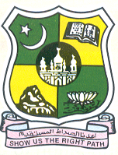
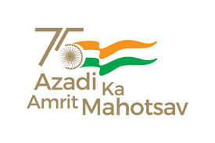
Accredited (3rd Cycle) with ‘A’ Grade by NAAC

(Affiliated to Bharathidasan University)

TIRUCHIRAPPALLI -620 020.

Since 1951

P.G. & Research Department of History Jamal Mohamed College takes pride in inviting you for a Special Lecture Programme of Maulana Abul Kalam Azad History Association on 8th September, 2022,Thursday at 10:30 A.M. at History Seminar Hall.

In the August Presence of
Hajee M.J.Jamal Mohamed Bilal Dr. A.K.Khaja Nazeemudeen
President Secretary & Correspondent
Hajee M.J.Jamal Mohamed Dr.K. Abdus Samad Dr. K.N. Abdul Khadar Nihal
Treasurer Assistant Secretary Member & Hon. Director

Dr.S.Ismail Mohideen

Principal, Jamal Mohamed College
has kindly consented to preside over the function
Dr.A.Mohamed Ibraheem
Vice Principal
Dr.M.Mohamed Sihabudeen
Additional Vice Principal
Dr.K.N. Mohamed Fazil Ms. J. Hajira Fathima
Director-Hostel Administration Director – Women Hostel
Special lecture on
“Teacher’s Role in Nation Building”

By

Major Dr. M.Viji
Former HOD of History
Holy Cross College
Tiruchirappalli- 620 002

Dr. M.MOHAMED TAJDEEN
Vice President

