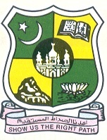
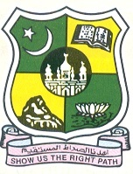
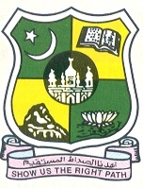
JAMAL MOHAMED COLLEGE (Autonomous)

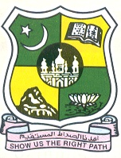
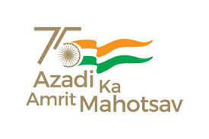
Accredited (3rd Cycle) with ‘A’ Grade by NAAC

(Affiliated to Bharathidasan University)

TIRUCHIRAPPALLI -620 020.

Since 1951
P.G. & Research Department of History Jamal Mohamed College takes pride in inviting you for the eve of Teacher’s Day Celebration by Maulana Abul Kalam Azad History Association on 6th September, 2022 at History Seminar Hall
Oratorical Contests: Ngr;Rg; Nghl;b
Role of Teacher in Development of My Life
vdJ tho;f;ifapd; Kd;Ndw;wj;jpy; Mrphpah;fspd; gq;F

S.No | Name of the Student | Class | Reg No | Signature
1 | Akash A | II MA History
2 | Mohamed Reeyasdeen A | II BA History
3 | Yasar Araffath A | I BA History
4 | Mohamed Ibrahim S | II BSc Maths
5 | Mohamed Rafiq S | II BSc Physics

Dr. M.MOHAMED TAJDEEN

Vice President

